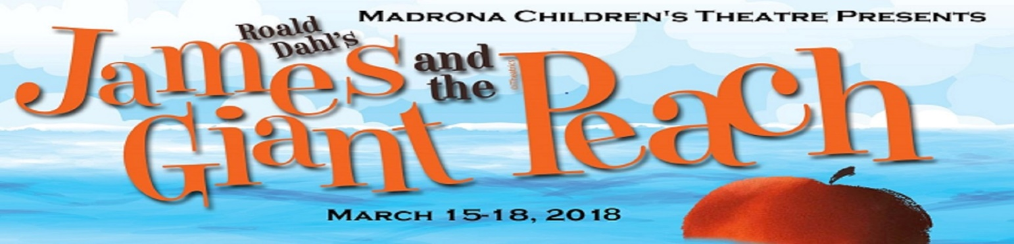
Peachy Pouch ($4)
Spiker and Sponge’s Chocolate Bar ($2)
Order by February 28th!
Candygrams are available for sale as a gift to any member of the production. They will be distributed during the last week of rehearsal at MLTHS. We cannot deliver to people who will not be present at those rehearsals.

You may order candygrams by returning this form to the MCT box in the main office, or to the forms box at rehearsal. Grams will be delivered during the week of March 12th at rehearsal. All grams must be paid for when ordered. Orders must be in by February 28th. Checks should be made out to MIT. Thanks for supporting Madrona Children’s Theatre and our cast and crew! Any questions can be directed to Matthew Appel at: mappel3@comcast.net or 425-418-4713. Please don’t forget to include your payment with this form!

Peachy Pouch ($4 for clear sack of gummy peaches and critters)
To (First & Last Name) | From | Message | Cast
 |  |  | Whi Won
 |  |  | Whi Won
 |  |  | Whi Won
 |  |  | Whi Won
 |  |  | Whi Won

Spiker and Sponge’s Chocolate Bar: ($2 for a wrapped Hershey bar)
To (First & Last Name) | From | Message | Cast
 |  |  | Whi Won
 |  |  | Whi Won
 |  |  | Whi Won
 |  |  | Whi Won
 |  |  | Whi Won
 |  |  | Whi Won

Ordered by: ________________________ Phone: ________________________
e-mail: ________________________

************************************************************************************

For MCT personnel: $___________received, confirmed by __________ on ___/____/2017 Check # ________ or Cash

