MIT Meeting Minutes
Date: March 8, 2023 Time: 6:30pm Location: Library
Meeting led by Molly Tobias and Carissa Castaldo, Parent Co-Chairs; notes taken by Jenny Miller, Recorder
Attendees: Remy Gutierrez, Treasurer; Greta Sullivan, Vice Treasurer; Lib Rust and Lizzy Stafford, Teacher Chairs

Upcoming / Important Dates

March 15-16 Half Day | March 17 No School
March 21 Class Pictures | March 29 STEAM Night 6-8pm
March 31 Half Day | April 3-7 Spring Break
April 12 MIT Meeting

Action Items
Approve Feb. Minutes | Not posted yet.  Minutes will be posted and approval will happen at the next meeting.

Speaker | Item | Action
Fabian | Principal Update-  Madrona Principal's position is open. District contacting Holly and Kelly about the process moving forward. Closes March 22nd.  School Board presentation March 28th. Madrona will present two powerpoints.  Students will be presenting on Syayəʔ and how that relates to our sense of belonging, inclusiveness.  Fabian will present on math goals, iReady, and strategies teachers are using.  MCT meeting coming up with a Zoom option available.  STEAM night March 29th.  Middle school students will work on Juneteenth,culture, inclusivity statements.  Collecting data from the second Panorama survey from students on feelings of safety, relationships with staff and students and sense of belonging. One more survey will happen in spring.
Mr. Barnes | Read for Adventure-  Elementary students read 8 hours and track time with QR code, fill Google form. Voucher to High Trek will be emailed in May.
Mr. Barnes | Madrona at the Mariners-  If middle schoolers read 16 hours they can be entered into a raffle for tickets. 10 tickets will be donated by Fabian.  MIT offered to donate another 10 tickets so now there will be 20 tickets available for the middle school raffle.  The Mariners game will be June 17 at 1pm.  Tickets cost $13 with $3 of that going to the PE fundraiser.  Tickets will go on sale after Spring Break.  Possible to donate tickets to families in need? | MIT will purchase an additional 10 tickets for the raffle.  Molly will email Mr. Barnes to discuss plans.
Remy | Treasurer Report-  Income  $100,000(including supply fees)  $43,500 Net Fundraising  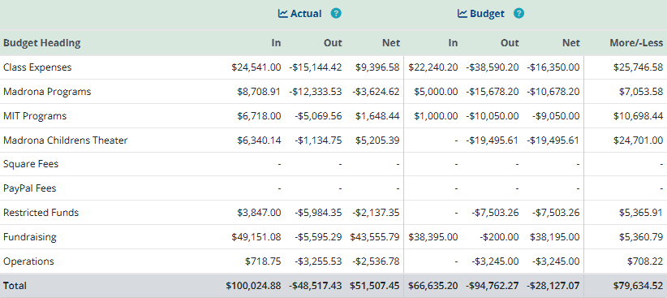 | Email MITREASURER@GMAIL.COM
Molly | Garden Club-  Melissa met with Down to Earth Community Gardens. Space was walked and may not be ideal for a vegetable garden. Will be working with Down to Earth to explore other options.  Vegetable seeds are available in the Family Room for anyone who would like to get some.
Molly | Steam Night-  March 29 Free for everyone.
Tanya  Molly | Art Auction-  Looking for funding for marketing. Facebook, Edmonds Beacon, etc.  $250 for Edmonds News banner, story.  $100 for postcards with artwork to sell.  $900 budget for Art Auction to be used for these. | Budget will be used for any marketing or purchases needed for the Art Auction.
 | ASB-  No representative at this meeting. | Update from ASB at next meeting.
 | SALT-  No representative at this meeting. | Update from SALT at next meeting.
Molly | Committees that need chairperson-  -Welcome Committee  -Band and Orchestra Booster Leaders
Molly | Open Board Positions-  -Vice Chair  Gina is retiring. Position needs to be filled.  -Treasurer  Remy will run for the position. More candidates are welcome. | Election is in April so candidates are needed now!
Molly | Art Auction Proceeds to be used towards-  Ms. Elena presented the idea of a mural created by a Tulalip Tribe Member artist for the Marona Campus.  Purchase art supplies for school.  - | Ms.Elena will be in contact with the artist to determine best placement of mural and cost estimate.
Gina  Lizzy  Molly  Gina | Is the Art Auction open to the public?  Has not been public in the past as people are in the classrooms.  Will need to discuss including the public before marketing as the Art Walk is also happening at the same time.  Book Fair will also be happening at the same time in the library. | Tanya will contact administration to clarify if this is an open to the public auction.
Carissa | Reminder that MIT does offer scholarships for students in need for field trips. | Families will receive reminders through Center communications.
Carissa | Will be stepping away as Co-Chair to head MCT.

